LibSpace – Library Management System

Project Documentation

1. Introduction

Project Title: LibSpace – Library Management System

Team Leader:
- Ashwini - ashwinicute06@gmail.com

Team Members:

1. N. Janani -janani02243@gmail.com
2. S. Subhadevi - Subhadevinkrcs@gmail.com
3. S.Umamakeswari - umankrcs@gmail.com

---

2. Project Overview

Purpose:
LibSpace is a web-based Library Management System designed to manage books, users, and borrowing activities efficiently. It helps librarians organize books, track issued books, manage returns, and maintain records digitally.

Features:

- User Registration and Login
- Add new books to the library
- Update book details
- Delete books from inventory
- View available books
- Issue books to users
- Return book management
- Search books by title, author, or category
- Admin dashboard

---

3. Architecture

Frontend:
HTML, CSS, JavaScript / React.js

Backend:
Node.js with Express.js

Database:
MongoDB / MySQL

---

4. Setup Instructions

Prerequisites

- Node.js
- MongoDB / MySQL
- Git
- Visual Studio Code

Installation Steps

git clone <repository-link>

cd client
npm install

cd ../server
npm install

---

5. Folder Structure

LibSpace/

|-- client/
| |-- components/
| |-- pages/
| |-- services/

|-- server/
| |-- routes/
| |-- models/
| |-- controllers/
| |-- config/

---

6. Running the Application

Start Backend

cd server
npm start

Start Frontend

cd client
npm start

Access Application

http://localhost:3000

---

7. API Documentation

User APIs

POST /api/user/register
POST /api/user/login

Book APIs

GET /api/books
POST /api/books/add
PUT /api/books/update/:id
DELETE /api/books/delete/:id

Borrow APIs

POST /api/borrow/book
POST /api/return/book
GET /api/borrow/history

---

8. Authentication

LibSpace uses JWT (JSON Web Token) for secure authentication.

- Users must log in to access the dashboard
- Protected routes require a valid token
- Tokens are verified on the server side

---

9. User Interface

The system contains the following pages:

- Login Page
- User Registration Page
- Dashboard
- Add Book Page
- Book List Page
- Issue Book Page
- Return Book Page
- User Management Page

---

10. Testing

Testing was performed manually during development.

Tools Used:

- Postman (API testing)
- Chrome DevTools
- Jest (optional unit testing)

---

- Screenshots / Demo
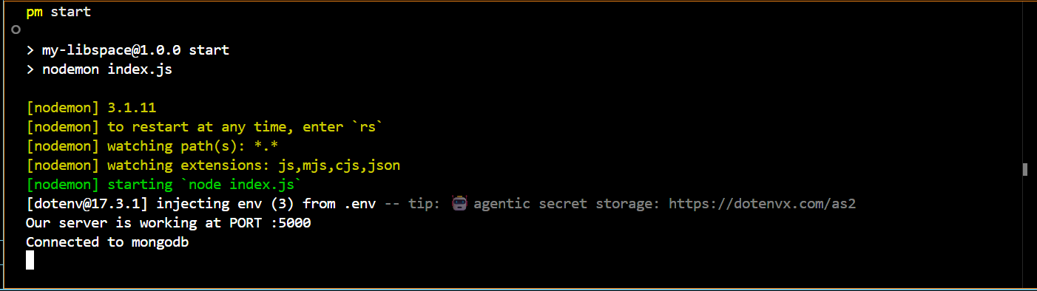
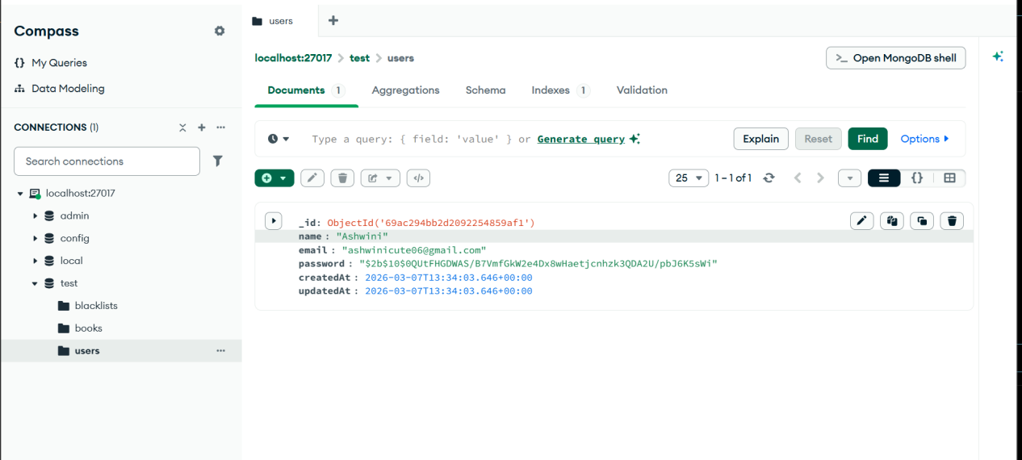
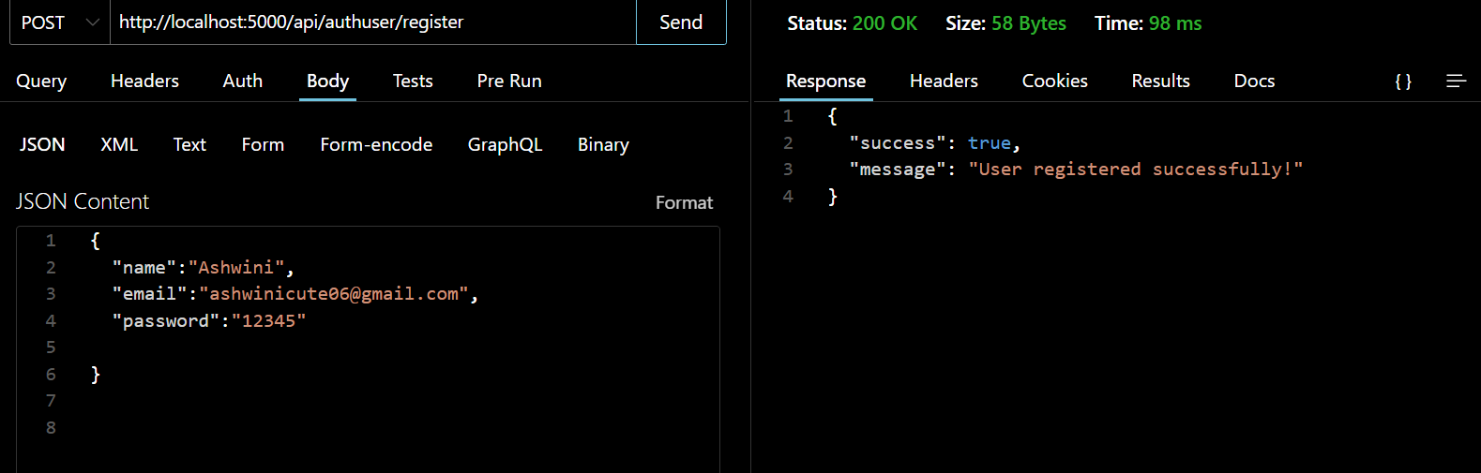
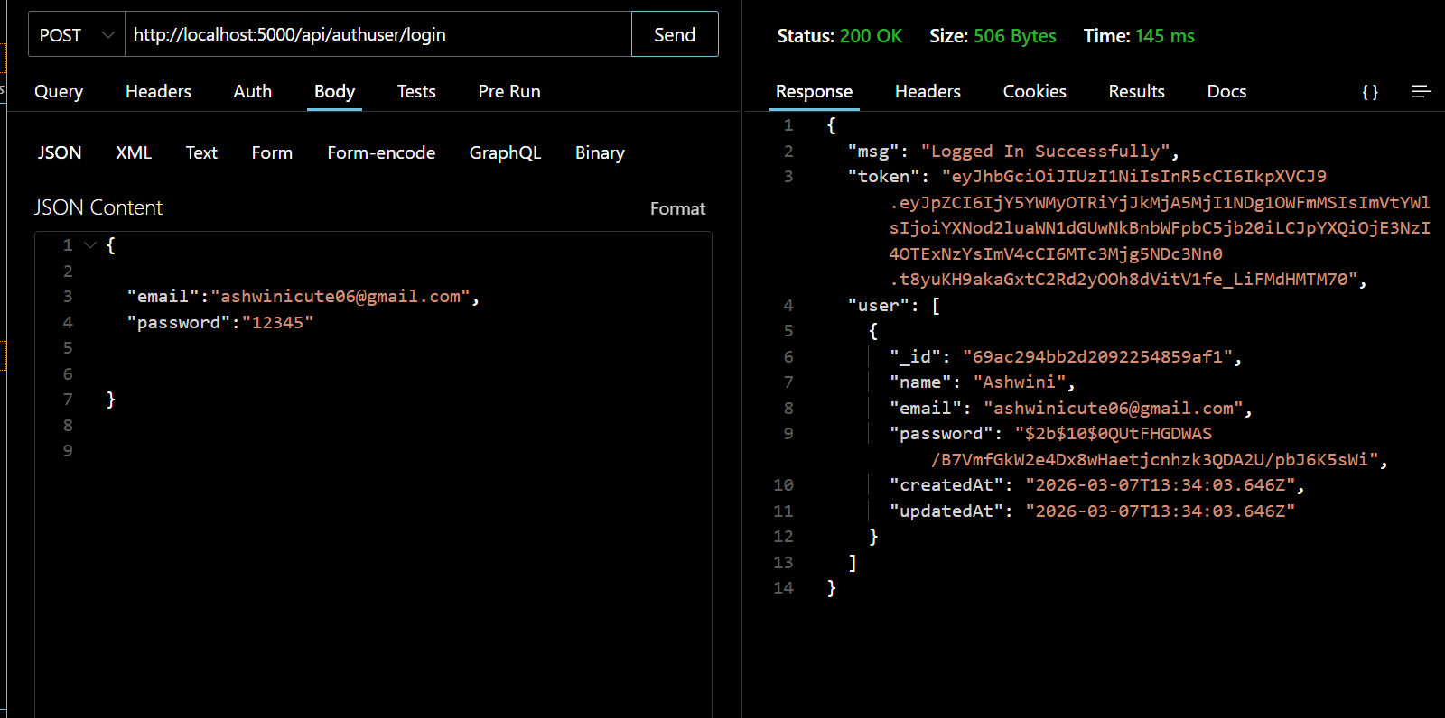

12. Known Issues

- Slow performance when handling a large number of books
- No barcode scanning feature
- Limited search filters

---

13. Future Enhancements

- Barcode or QR code book scanning
- Mobile application support
- Email reminders for book return dates
- AI-based book recommendation system
- Cloud database integration

---

14. Sample Backend Code (Node.js + Express)

const express = require("express");
const app = express();

app.use(express.json());

let books = [];

app.get("/books", (req, res) => {
res.json(books);
});

app.post("/books", (req, res) => {
const book = req.body;
books.push(book);
res.json({ message: "Book added successfully" });
});

app.put("/books/:id", (req, res) => {
const id = req.params.id;
books[id] = req.body;
res.json({ message: "Book updated" });
});

app.delete("/books/:id", (req, res) => {
const id = req.params.id;
books.splice(id, 1);
res.json({ message: "Book deleted" });
});

app.listen(3000, () => {
console.log("Server running on port 3000");
});

